Open SAP Build work zone, standard edition
Before this assign the required Roles to the user and login.
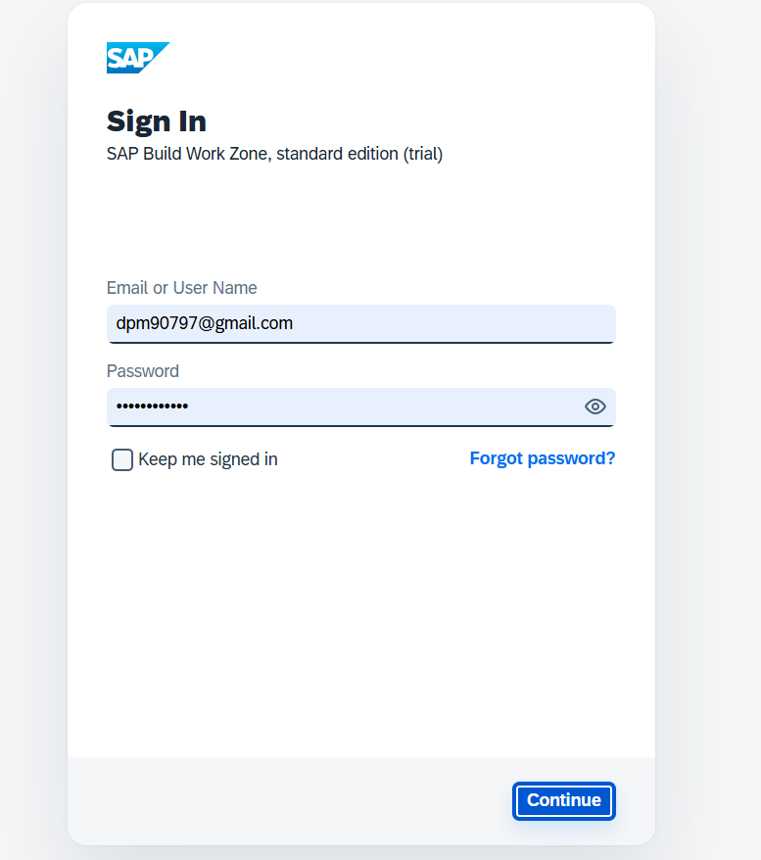

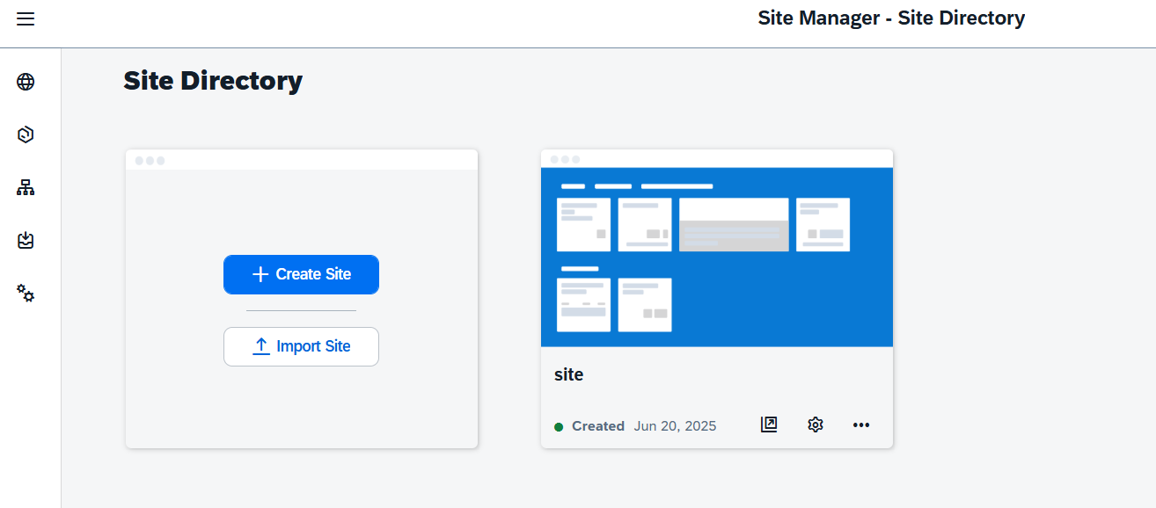
Click on the 3 side rows and open channel manager.
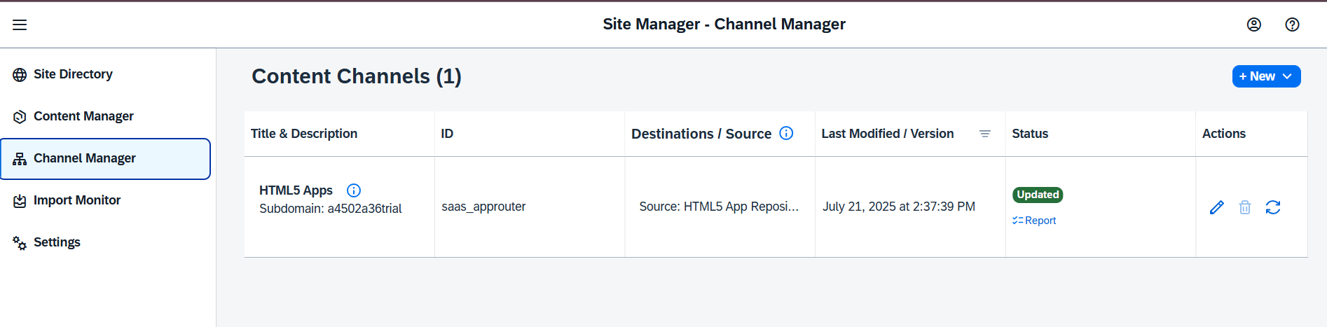
Then go to content manager and click on content explorer.
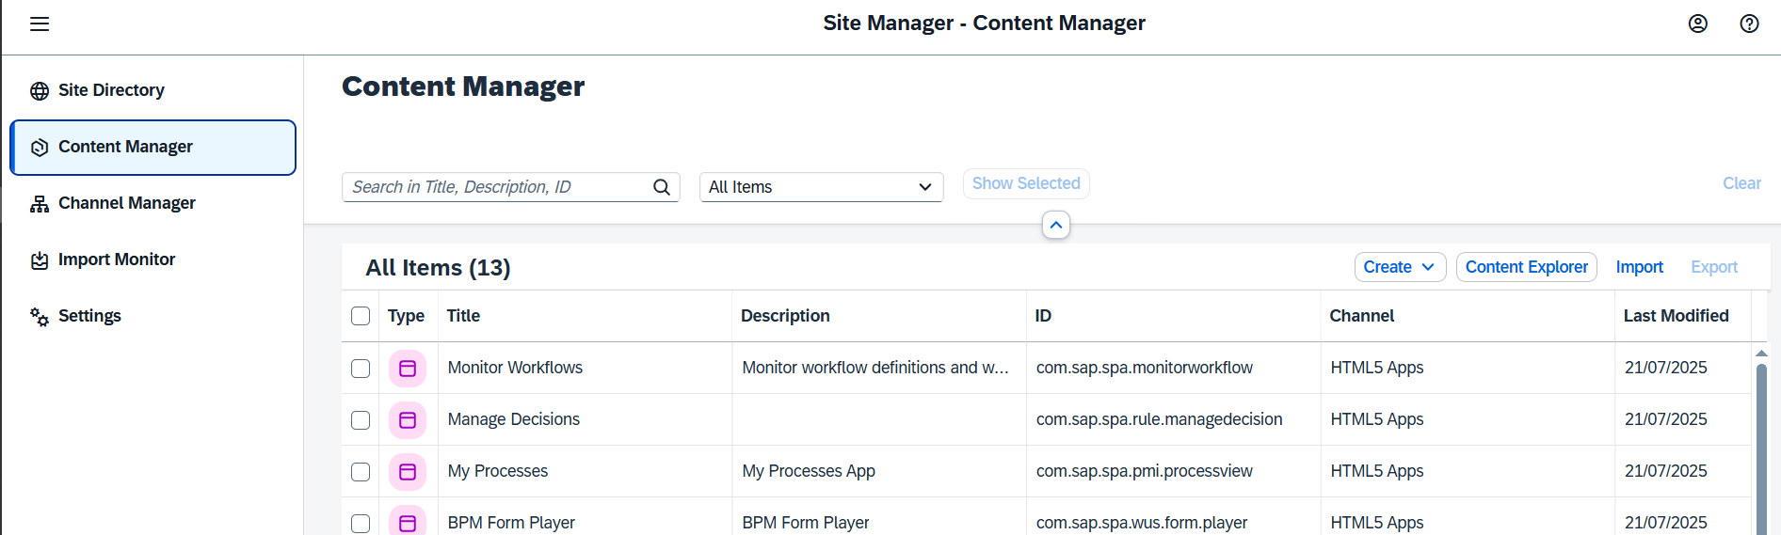
And click on HTML5
And add all the application present there using add button.
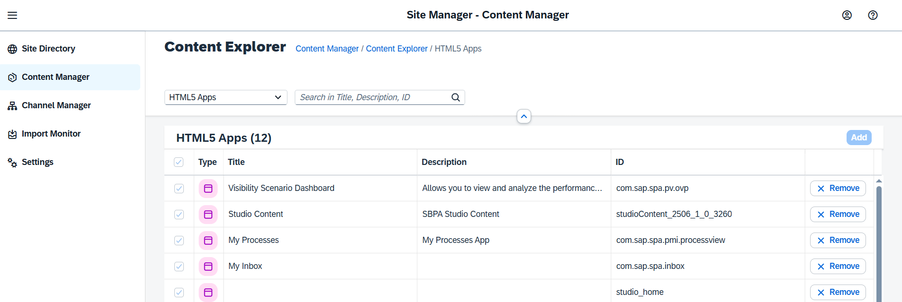

Completed you have configured all the required apps with my inbox app in the HTML5 application.

